**Separation of a Mixture**

Sean Poston

Dr. Ragain

CH184

lab performed 5/28/2021

lab submitted 5/29/2021

**Introduction**

This lab explored the idea of taking a mixture of four different substances, separating them out, and trying to recover them through different means. The mixture contained iron, sand, benzoic acid, and sugar (Carolina). These were all in equal parts in one bottle before I tried to separate them and measure their mass. Of course, in doing so, I made errors that resulted in the loss of some parts of the mixture along the way.

As an example of an error, when pouring water from the solution after the iron was removed, I absolutely let some solid pieces of sand float out of it, resulting in a loss of mass from the result. Another error is that I forgot to measure the mass of the empty Styrofoam cup before adding anything to it. I got a rough estimate of it, but it will still not be as accurate as it could be. Also, the substances were most likely still a little bit wet when I weighed them. I waited overnight, but I did not have the time to wait anymore.

There are many ways to separate out a mixture (CCRI). The ones we used were decanting, filtration, extraction, and some form of distillation where the water was heated enough to melt certain substances, but not others. Then it passed through a filter to maintain the old substance. Processes like this were used for the whole lab to separate the mixture into its four component parts.

**Photos**

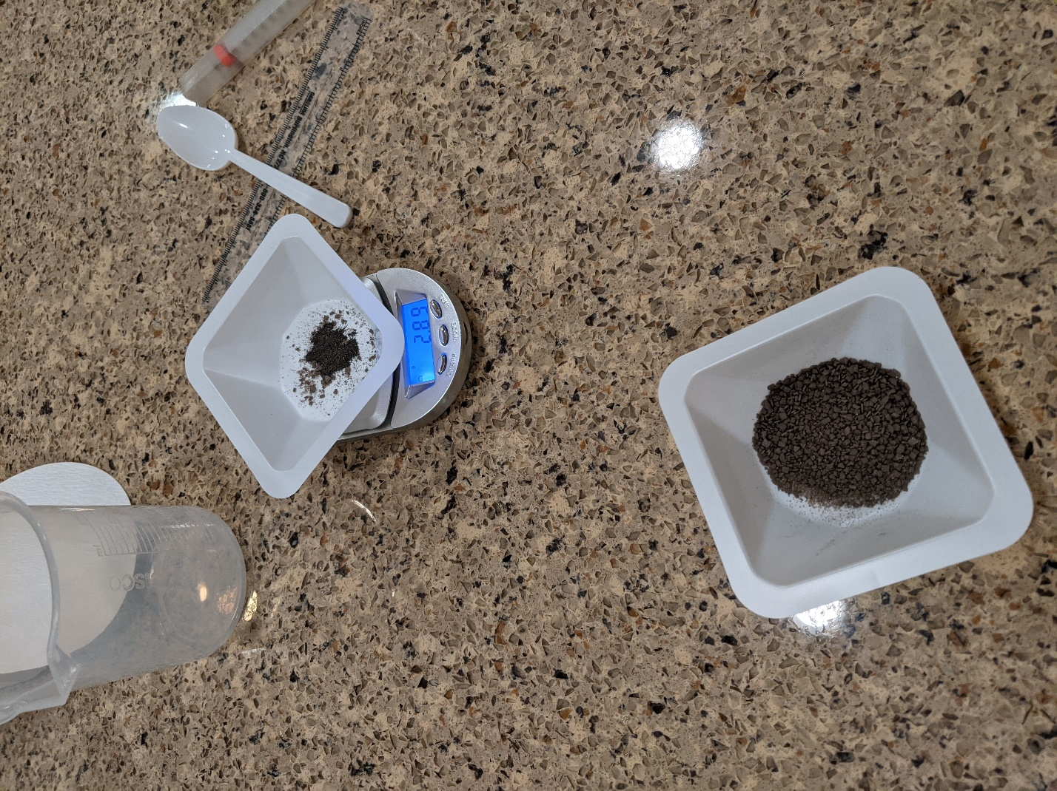

Figure : Weighing Iron

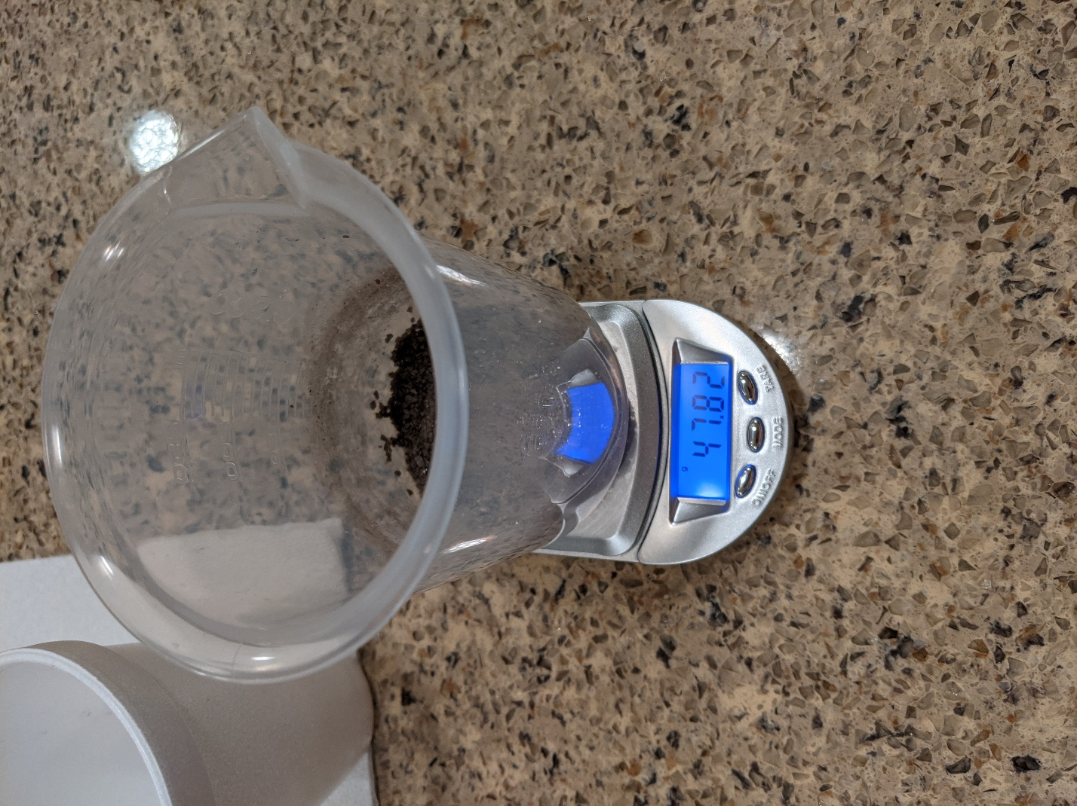

Figure : Sand and Beaker

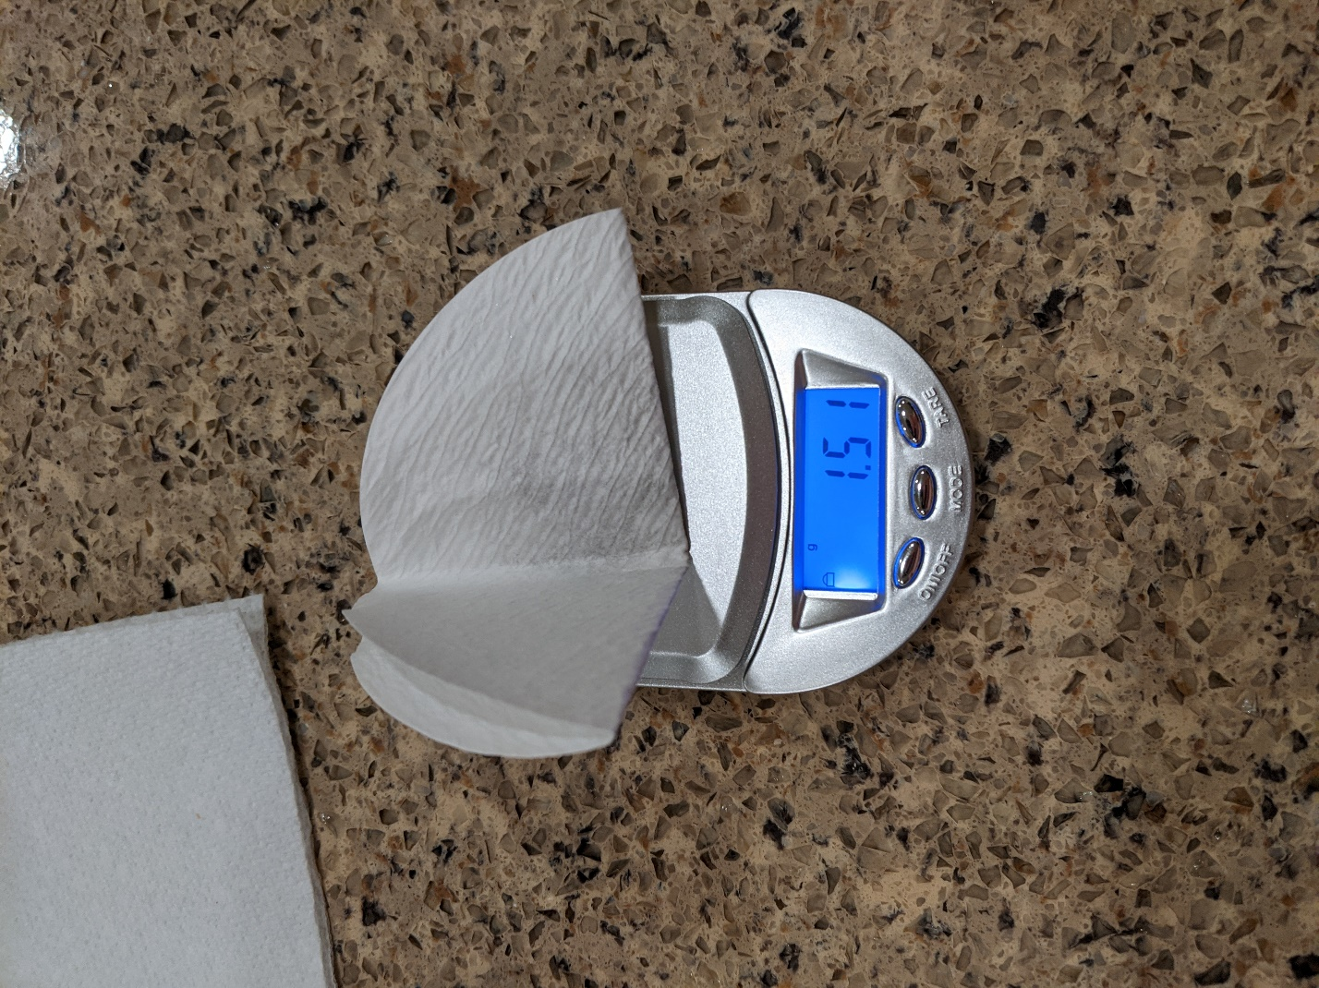

Figure : Benzoic Acid and Filter Paper

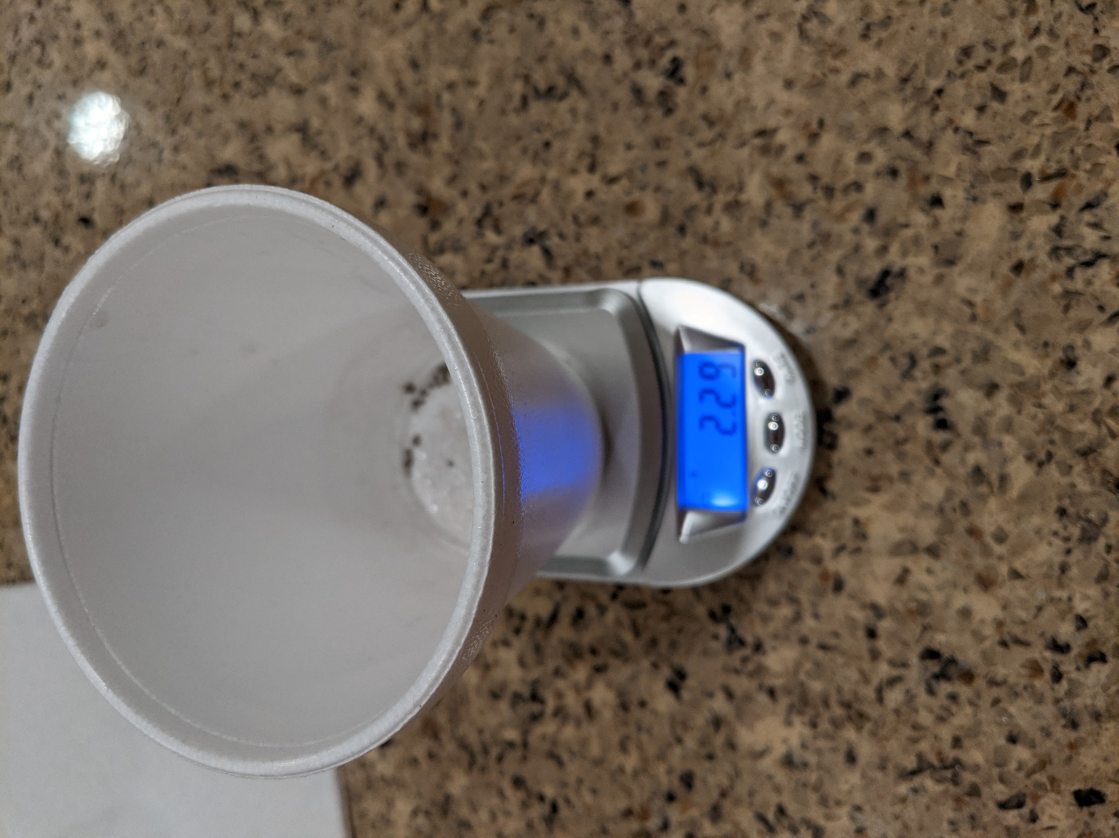

Figure : Sucrose and Foam Cup

**Datasheet**

Data Table 1

|  |  |
| --- | --- |
| **Object** | **Mass (g)** |
| **Mixture sample** | 4.80 |
| **Iron filings** | 2.89 |
| **Empty plastic beaker** | 44.9 |
| **Beaker and sand** | 47.8 |
| **Sand** | 2.90 |
| **Filter paper** | 1.27 |
| **Filter paper and benzoic acid** | 1.51 |
| **Benzoic acid** | .240 |
| **Empty foam cup** | 2.05 |
| **Foam cup and sucrose** | 2.29 |
| **Sucrose** | .240 |

**Data Table 2**

|  |  |
| --- | --- |
| **Object** | **Mass (g)** |
| **Iron filings** | 2.89 |
| **Sand** | 2.90 |
| **Benzoic Acid** | .240 |
| **Sucrose** | .240 |
| **Total Mass of Components** | 6.27 |
| **Original Mass of Mixture Sample** | 4.8 |
| **Percentage Recovery** | 130.6% |

1. How did the total mass of the recovered chemicals compare to the original mass of the sample?

**I ended up with more.**

1. If your recovery mass was noticeably different from the original mass, can you determine some reasons for this discrepancy?

**I absolutely measured certain things incorrectly and even forgot to take some control measurements of containers.**

1. Which chemical in the separation do you believe was the most accurate to the original mass in the sample?  Why?

**I think the iron was close, but even with that I believe I included the weight of the weight boat. Typing this, I now realize I ruined every single step of this lab.**

1. Which chemical in the separation do you believe was the least accurate to the original mass in the sample?  Why?

**The sucrose because I forgot to measure the cup ahead of time completely. This led to me giving an educated guess on the initial weight of the cup.**

**Calculations**

The calculations performed in this lab were mostly basic arithmetic. To find the remaining weight of the substances, I simply had to subtract the initial mass of the empty container from the final mass of the container with the substance.

Also, to find the percent of substance recovered, a simple percentage equation is used (Carolina).

**Conclusion**

I could’ve performed this lab much better to get a higher on the substances. I made a few errors along the way that led to a lower accuracy that I would’ve liked. However, the lab is complete, and that can’t be fixed now. More of a heads-up from either Carolina or the instructor would be nice on this lab as you’re expected to leave things overnight or even longer (I’m not blaming, but just a thought for future students. I’m sure it’s less of a problem in an in-person, sixteen-week class as well).

The lab was truly interesting in the sense of using different methods to separate the parts of the mixture. I feel like it gave me new ideas on how to perform this in the real world if the need ever arises. Overall, the lab was quick and easy, but I still feel like I took away a lot from it.

**References**

Carolina. Separation of a Mixture Investigation Manual. Accessed 28 May 2021.

CCRI. Physical Separation. https://www.ccri.edu/chemistry/courses/chem_1030/Physical_Separation.pdf

Obligatory Selfie

